Homework 8: Introduction to ANOVA and Post-Hoc Tests

t-tests: Questions 1-2
ANOVA: Questions 3-6
SPSS: ANOVA

One-way between subjects ANOVA (Describe the conditions under which you would perform the test (e.g., how many groups, type of data, when each person in the study is measured once or twice and you want to compare the means of dependent samples, etc.). Include the type of data the test analyzes (e.g., equal-interval), any assumptions that must be made (e.g., normal population distribution), the characteristics of the comparison distribution, and an explanation of the logic of the test (using simple language))

SPSS Homework: Although this assignment involves computing a one-way ANOVA, we will use the GLM command instead of the one-way ANOVA command because it will be used for when we analyze data for the Factorial ANOVA. (The GLM approach does not allow for running planned comparisons/contrasts. You can use the one-way ANOVA approach if you ever need to run planned comparisons. Despite this GLM limitation, I find that students benefit from learning the GLM approach because it will help you when you do future analyses with the same command. )

Note: ANOVA Notation: Although the logic of ANOVA is always the same, notation is not always consistent between different textbooks and courses. Sometimes the Model Sum of Squares is the same concept as Sum of Squares Between-Groups; Residual Sum of Square is the same concept as Sum of Squares Within-Groups.

- Enter the following data.
A psychologist at a private mental hospital was asked to determine whether there was a clear difference in the length of stay of patients with different categories of diagnosis. Looking at the last four patients in each of the three major categories, the results (in terms of weeks of stay) were as follows:

Diagnosis Category

Affective Disorders | Cognitive Disorders | Drug-Related Conditions
7 | 12 | 8
6 | 8 | 10
5 | 9 | 12
6 | 11 | 10

(Data Entry Hint: Remember that each person is a row when entering your data and that you have three different conditions to which people are assigned).

- Look at your data using a graph to make sure you have met the assumptions for ANOVA tests. What do the variances in scores look like for each group? Are there any outliers?

- Run a one-way ANOVA comparing all three groups. Use Analyze → General Linear Model → Univariate. Once in the ANOVA screen designate your dependent variable (in the dependent list), and independent variable (under fixed factor). Before running the procedure, press Options button and check the descriptive statistics, homogeneity of variance tests, estimates of effect size boxes. Also, press Post Hoc and select a Scheffé and Tukey as post-hoc tests. Technically, you would choose only one post-hoc test, but for educational purposes select these two for comparison purposes.

- On the output:
- Circle the p-value for the Levene’s test and indicate what this tells you in terms of the variables in the study. Hint: related to a statistical assumption.
- Label the values for and p value.
c. Demonstrate your knowledge of Mean Squares and the F ratio by showing how SPSS calculated: and the p value for the ANOVA.
d. Next to the p-value for the F test, indicate whether or not the result is significant and indicate how you know this (use the .05 level). Also indicate what this significant or non-significant result means in terms of the variables in the study.
- Circle the p-values for the 3 post hoc comparisons and indicate what they tell you regarding specific differences between each of the groups (e.g., NHST).
____________________________________________________________________________

Student’s t-test

- Identify when you would want to use a z-test, a one sample t-test, and a dependent samples t-test.

- What question does an independent samples t-test allow you to address?

ANOVA

- Using the following data,

 | Group 1 | Group 2 | Group 3
 | 8 | 6 | 4
 | 8 | 6 | 4
 | 7 | 5 | 3
 | 9 | 7 | 5

  - Decide whether you can reject the null hypothesis that the groups come from identical populations. Use the .01 alpha level for rejecting the null hypothesis. In order to do so, you will have to conduct the appropriate statistical analysis. Please remember to identify the null hypothesis and alternative hypothesis.

  - Calculate the effect size using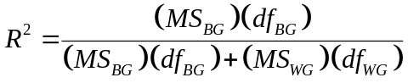

- What is the Bonferonni corrected significance level for each of the following situations?

 | Overall Significance Level | Number of Planned Contrasts
 | .05 | 2
 | .05 | 4

- The table below (Hazan and Shaver, 1987) shows comparisons on various dependent variable for groups of children who differ in social attachment (Avoidant, Anxious/Ambivalent, and Secure). The table displays F statistics along with p values and lettered subscripts that indicate significant differences as determined by Scheffé test. Indicate for which dependent variable variables show that:
  - the Avoidants differ significantly from the other two groups
  - the Anxious-Ambivalents differ significantly from the other two groups
  - the Secures differ significantly from the other two groups
  - three groups differ significantly from one another
  - Now to yourself aloud what a Scheffé test is and what it is used for

Table | Love the subscale means for the three attachment types (newspaper sample)
Scale Name |  | Avoidant | Anxious/  Ambivalent | Secure | F (2, 571)
Happiness |  | 3.19_{a} | 3.31 _{a} | 3.51 _{b} | 14.21***
Friendship |  | 3.18 _{a} | 3.19 _{a} | 3.50 _{b} | 22.96***
Trust |  | 3.11 _{a} | 3.13 _{a} | 3.43 _{b} | 16.21***
Fear of closeness |  | 2.30 _{a} | 2.15 _{a} | 1.88 _{b} | 22.65***
Acceptance |  | 2.86 _{a} | 3.03 _{b} | 3.01 _{b} | 4.66**
Emotional extremes |  | 2.75 _{a} | 3.05 _{b} | 2.36 _{c} | 27.54***
Jealousy |  | 2.57 _{a} | 2.88 _{b} | 2.17 _{c} | 43.91***
Obsessive preoccupation |  | 3.01 _{a} | 3.29 _{b} | 3.01 _{a} | 9.47***
Sexual attraction |  | 3.27 _{a} | 3.43 _{b} | 3.27 _{a} | 4.08*
Desire for union |  | 2.81 _{a} | 3.25 _{b} | 2.69 _{a} | 22.67***
Desire for reciprocation |  | 3.24 _{a} | 3.55 _{b} | 3.22 _{a} | 14.90***
Love at first sight |  | 2.91 _{a} | 3.17 _{b} | 2.97 _{a} | 6.00**
Note: within each row, meetings with different subscripts differ at the .05 level of significance according to a Scheffé test.
*p < .05; **p < .01; ***p < .001
Source: Hazan C., & Shaver, P (1987). Romantic love conceptualized as an attachment process. Journal of personality and social psychology, 52, 511-524.

- An experiment is conducted in which 60 participants each fill out a personality test, but not according to the way the participants see themselves. Instead, 15 participants are assigned randomly to complete the tasks according to the way they think their mothers see them (that is, the way they think their mothers would fill out the test to describe the participants); 15 participants complete the forms as their fathers would complete it for them; 15 participants completed as their best friends would complete it for them; and 15 completed as their professors who they know best would complete it for them. The main results appear in the table below. Interpret/explain the results.

Table | Means for main personality scales for each experimental condition (fictional data)
Scale Name |  | Mother | Father | Friend | Prof. | F(3, 56)
Conformity |  | 24 | 21 | 12 | 16 | 4.21*
Extroversion |  | 14 | 13 | 15 | 13 | 2.05
Maturity |  | 15 | 15 | 22 | 19 | 3.11*
Self-confidence |  | 38 | 42 | 27 | 32 | 3.58*
*p < .05; **p < .01

Homework 8
Answers

- When to use a z-test, one sample t-test, and dependent samples t-test.

The z-test is an inferential statistic used to compare a sample mean to a population mean, when a population’s mean and standard deviation are known.
Formula: Z= 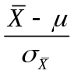

The one sample t-test is used to determine whether a single sample mean differs from a known population mean more than we might expect due to chance. You compare the sample score distribution to a population distribution.
Formula: 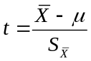

The dependent samples t-test is used to compare two related samples; these could be repeated measures of the same unit or matched experimental units. You compare the difference score between the two samples, then compare that to a theoretical distribution of difference scores under the null hypothesis.
Formula: 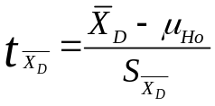

- Independent samples t-test.

An independent samples t-test answers the question “is the distribution of differences between sample means greater than what you would expect if the populations from which those samples were drawn do NOT actually differ?”

When we answer that question with an independent samples t-test, we compute sample means, compare the differences between them, and determine if the samples differ greater than expected due to chance. If the sample means come from different parent populations, we usually hope our data suggest the same outcome; we hope for a statistical difference or rejection of the null hypothesis.
Formula: 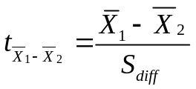

- Three Groups Problem

  - Do the groups come from identical populations?
1. Population 1 = Group 1²
Population 2 = Group 2
Population 3 = Group 3

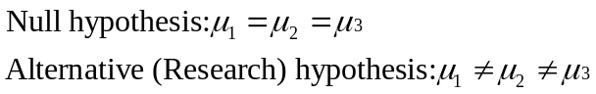

2. Characteristics of the Null (comparison) Distribution:
F distribution with 2,9 df.
df_{BG} = # of groups -1 = 3-1 = 2
df_{WG} = df₁+df₂+df₃ = 3+3+3 = 9

3. F- cutoff_{α .01}, [df_{BG} (numerator) = 2, df_{WG} (denominator) = 9] = 8.02
F (2, 9) = 8.02

4.
 |  | Group 1
X | 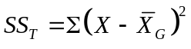 |  | 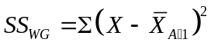 |  | 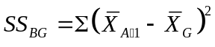
8 | 8-6=2 | (2²)= 4 | 8-8=0 | (0²)= 0 | 8-6=2 | (2²)= 4
8 | 8-6=2 | (2²)=4 | 8-8=0 | (0²)= 0 | 8-6=2 | (2²)= 4
7 | 7-6=1 | (1²)=1 | 7-8=-1 | (-1²)= 1 | 8-6=2 | (2²)= 4
9 | 9-6=3 | (3²)=9 | 9-8=1 | (1²)= 1 | 8-6=2 | (2²)= 4
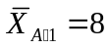 | SS_{T} = 4+4+1+9=18 |  | SS_{WG} = 0+0+1+1=2 |  | SS_{BG} = 4+4+4+4=16  Or 4(n)=4(4)=16
 |  | Group 2
X |  |  | 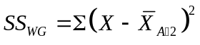 |  | 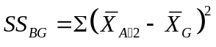
6 | 0 | 0 | 0 | 0 | 0 | 0
6 | 0 | 0 | 0 | 0 | 0 | 0
5 | -1 | 1 | -1 | 1 | 0 | 0
7 | 1 | 1 | 1 | 1 | 0 | 0
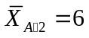 | SS_{T} = 2 |  | SS_{WG} = 2 |  | SS_{BG} = 0
 |  | Group 3
X |  |  | 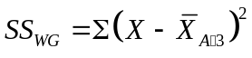 |  | 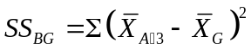
4 | -2 | 4 | 0 | 0 | -2 | 4
4 | -2 | 4 | 0 | 0 | -2 | 4
3 | -3 | 9 | -1 | 1 | -2 | 4
5 | -1 | 1 | 1 | 1 | -2 | 4
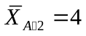 | SS_{T} = 18 |  | SS_{WG} = 2 |  | SS_{B} = 16
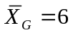 | SS_{Total} = 38 |  | SS_{WG} = 6 |  | SS_{BG} = 32

Note: Creating an ANOVA table as shown below will help you identify df, SS, MS, and F values. Please make sure to practice learning the relationship between these concepts. Creating ANOVA tables on your own will help you learn these relationships and will help you identify piece of information from a table that has missing information.

ANOVA Summary table
Source | SS | df | MS | F-ratio
Between | 32 | a-1=3-1=2 | 32/2 = 16 | 23.88
Within | 6 | a(n-1)=3(3)=9 | 6/9 = .67
Total | 38 | 11

Decision: Because the calculated omnibus F(2, 9) = 23.88 is greater than the cutoff F(2, 9) = 8.02, we reject the null hypothesis and conclude that the results reached statistical significance. There is some difference between the groups, though, and post-hoc analyses are needed in order to determine exact nature of difference.

3b.
Effect size = R² = 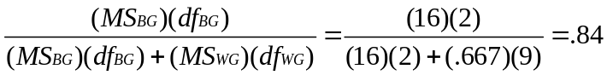

This effect size is large: 84% of the variance in individual scores is accounted for by the IV (only 16% is accounted for variables other than the IV; variables not investigated, error, etc.)

- Bonferroni Question
  - With = .05, and the number of planned contrasts = 2, the Bonferroni corrected significance level = 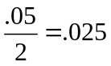

  - With = .05, and the number of planned contrasts = 4, the Bonferroni corrected significance level = 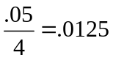

- Attachment Question

  - Avoidant folks significantly differed from the other two groups for: acceptance (avoidants < other two groups; anxious = secure), emotional extremes (all groups differed: avoidants < anxious; avoidants > secure; anxious > secure), jealousy (all groups differed: avoidants < anxious; avoidants > secure; anxious > secure).

  - Anxious-Ambivalents scored significantly higher than the other two groups on: emotional extremes, jealousy, obsessive pre-occupation, sexual attraction, desire for union, desire for reciprocation, and love at first sight.

  - Secure folks scored significantly higher than the other two groups on happiness, friendship, and trust, but scored significantly lower on fear of closeness, emotional extremes, and jealousy.

  - All three attachment groups significantly differ under the variables: emotional extremes and jealousy.

  - After determining that an omnibus ANOVA is significant, researchers often conduct exploratory analyses in order to determine which levels of an IV are different from the other levels. Analyses that are not planned before the omnibus ANOVA and compare each pair of groups after the ANOVA is run are called post-hoc (after the fact) comparisons. The problem is that, with many comparisons, some may be statistically different by chance factors alone because the supposed significance level of, say, .05. As the number of comparisons, increases the likelihood of making alpha errors increases. When conducting post-hoc tests, special mathematical procedures have been developed to keep the familywise error rate at the intended level, say .05 if the null hypothesis is actually true. The Scheffé test is an example of this kind of procedure.

- Personality Test Results

Explanation for non-stats person: A researcher conducted an experiment to determine if people differ in the way they fill out a personality test when they do so from others’ perspectives. 60 participants were asked to fill out the personality test from either: a) their mother’s perspective, b) their father’s perspective, c) a friend’s perspective, or d) a professor’s perspective. 15 participants were assigned to each perspective group. The personality test measured a person’s conformity, extroversion, maturity, and self-confidence. The question at hand was: do people rate their levels of conformity, extroversion, maturity, and self-confidence differently depending upon the perspective they are assigned to use?
After all participants completed the test, the researchers analyzed the scores from the personality scales. They averaged the scores of the participants writing from each of the perspectives, and compared the averages of the perspectives. Because each individual is unique, it is unlikely that the average score for each person will be exactly the same and it is unlikely that the average scores for each personality scale would be exactly the same for the different perspective ratings. However, the researchers want to determine how likely it is that there will be differences in the average personality scores for each experimental group, if people in general do not differ in the way they rate themselves according to others’ perspectives.
The researchers found that when participants in the different perspective groups rated their levels of conformity, the average of their scores were very different. In fact, those differences are likely to occur only one time out of a hundred tests if people in general do not have different self-ratings when they respond from these perspectives. The researchers also found a large difference between the self-rating perspectives when participants rated their maturity and self-confidence, although the differences for these perspectives were likely to occur 5 times out of a hundred tests if people in general do not differ. The researchers conclude that these results are so unlikely if we assume that people really don’t differ on these self-ratings from the different perspectives that we can decide that people do appear to differ on these personality ratings depending upon whose perspective they write from. Finally, when participants rated their levels of extroversion, the different perspectives did not produce differences that were very unlikely if people in general do not differ in self-ratings from these perspectives. The final conclusion from these results is that people do seem to differ in how they describe themselves on several personality measures depending upon the perspective they take to describe themselves. However, people do not seem to differ in self-ratings of extroversion when writing from the different perspectives. Further analysis will have to be conducted in order to determine the nature of these differences.
Participants writing from their parents’ perspectives appeared to rate their conformity higher than the participants writing from the friends’ or the professor’s perspective. However, further analysis is needed in order to determine which particular perspective produces a difference that is unlikely to occur given that people in general do not differ on these measures. Maturity ratings from the parents’ perspectives produced lower ratings than the friend’s or professor’s perspective. Participants indicated higher self-confidence ratings when writing from their parents’ perspectives than when writing from the friend’s or professor’s perspective. However, as with the conformity ratings, further analysis was deemed as needed in order to determine the nature of these differences.

Statistical test:

One-way ANOVA (between-subjects)

We use an ANOVA when we have one independent variable (or factor), three or more experimental groups/conditions, and we want to determine if there is a statistically significant difference between the means of the groups.
The essential logic behind ANOVA is that we are producing two independent estimates of the same population variance. One of the estimates is based on the variability of the group means and the other is based on the variability within the groups. If the assumption that all the groups come from the same population is true, the ratio between the two estimates should equal to one (numerator differences would be due to random error alone and not due to the IV). If the two variance estimates indicate that variability between groups is greater than variability within groups, then the ratio between the two estimates will be greater than one. This outcome might indicate that that the groups really represent different populations (populations related to the levels of the IV). We use the size of this ratio to determine whether a statistically significant difference exists between the group means. The distribution of an F ratio with a particular set for numerator and denominator degrees of freedom serves as our comparison distribution (the F distribution). In other words, it’s the sampling distribution of the ratio of two independent estimates of the variance of a normal distribution.
For, ANOVA we use continuous data for the dependent variable and we assume that the population distributions are normally distributed. We also assume homogeneity of variance (that the variance is equal among the population distributions) and independence of our observations.

SPSS Assignment
Syntax

Examine data with a scatterplot:
GGRAPH
/GRAPHDATASET NAME="graphdataset" VARIABLES=Diagnosis LengthStay MISSING=LISTWISE REPORTMISSING=NO
/GRAPHSPEC SOURCE=INLINE.
BEGIN GPL
SOURCE: s=userSource(id("graphdataset"))
DATA: Diagnosis=col(source(s), name("Diagnosis"), unit.category())
DATA: LengthStay=col(source(s), name("LengthStay"))
GUIDE: axis(dim(1), label("Diagnosis Category"))
GUIDE: axis(dim(2), label("Weeks of Stay in Hospital"))
SCALE: cat(dim(1), include("1", "2", "3"))
SCALE: linear(dim(2), include(0))
ELEMENT: point(position(Diagnosis*LengthStay))
END GPL.

Examine data with boxplots:
GGRAPH
/GRAPHDATASET NAME="graphdataset" VARIABLES=Diagnosis LengthStay MISSING=LISTWISE REPORTMISSING=NO
/GRAPHSPEC SOURCE=INLINE.
BEGIN GPL
SOURCE: s=userSource(id("graphdataset"))
DATA: Diagnosis=col(source(s), name("Diagnosis"), unit.category())
DATA: LengthStay=col(source(s), name("LengthStay"))
DATA: id=col(source(s), name("$CASENUM"), unit.category())
GUIDE: axis(dim(1), label("Diagnosis Category"))
GUIDE: axis(dim(2), label("Weeks of Stay in Hospital"))
SCALE: cat(dim(1), include("1", "2", "3"))
SCALE: linear(dim(2), include(0))
ELEMENT: schema(position(bin.quantile.letter(Diagnosis*LengthStay)), label(id))
END GPL.

Run univariate ANOVA:
UNIANOVA LengthStay BY Diagnosis
/METHOD=SSTYPE(3)
/INTERCEPT=INCLUDE
/POSTHOC=Diagnosis(TUKEY SCHEFFE)
/PRINT=ETASQ HOMOGENEITY DESCRIPTIVE
/CRITERIA=ALPHA(.05)
/DESIGN=Diagnosis.

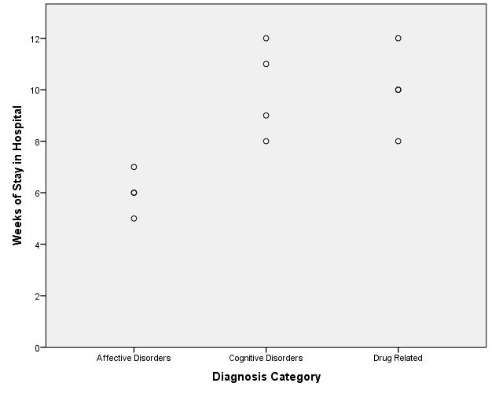

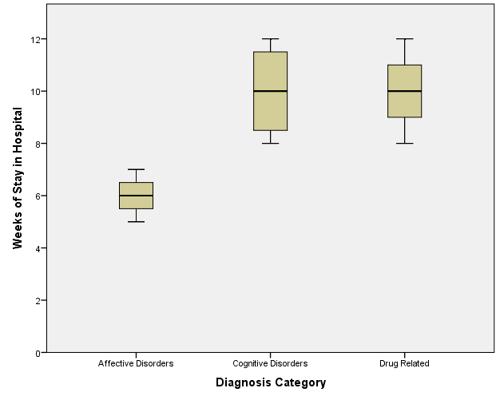

Descriptive Statistics
Dependent Variable: Weeks of Stay in Hospital
Diagnosis Category | Mean | Std. Deviation | N
Affective Disorders | 6.00 | .816 | 4
Cognitive Disorders | 10.00 | 1.826 | 4
Drug Related | 10.00 | 1.633 | 4
Total | 8.67 | 2.387 | 12
The three groups have different standard deviations. We need to check that they are not too different so we meet the assumptions for comparing groups in an ANOVA.
Levene’s Test is not significant (p >0.05). We fail to reject the null hypothesis that the error variance of each group is equal.
Levene's Test of Equality of Error Variancesª
Dependent Variable: Weeks of Stay in Hospital
F | df1 | df2 | Sig.
1.500 | 2 | 9 | .274
Tests the null hypothesis that the error variance of the dependent variable is equal across groups.
a. Design: Intercept + Diagnosis

4b.
Tests of Between-Subjects Effects
Dependent Variable: Weeks of Stay in Hospital
Source | Type III Sum of Squares | df | Mean Square | F | Sig. | Partial Eta Squared
Corrected Model | 42.667ª | 2 | 21.333 | 9.600 | .006 | .681
Intercept | 901.333 | 1 | 901.333 | 405.600 | .000 | .978
Diagnosis | 42.667 | 2 | 21.333 | 9.600 | .006 | .681
Error | 20.000 | 9 | 2.222
Total | 964.000 | 12
Corrected Total | 62.667 | 11
a. R Squared = .681 (Adjusted R Squared = .610)
This row has SS_{Total} and df_{Total}.
F (2, 9) = 9.60, p = 0.006
(significant result)

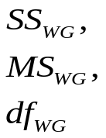
This row has
.

4c. Demonstrate your knowledge of Mean Squares and the F ratio by showing how SPSS calculated:
Df total= 4 + 4 +4 -1= 11
df_{WG} = “Error”= (4-1) + (4-1) + (4-1) = 9
df_{BG} = “Corrected Model”= (3-1)= 2
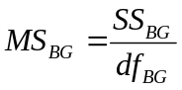 = 42.67/2.00= 21.33
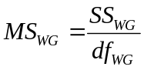= 20/9 = 2.22
F (2, 9)= / = 21.33/2.22 = 9.60

4d. Using the one-way ANOVA, we tested whether there was a significant difference in mean number of weeks of stay between the three groups. We found that there was a significant difference between the groups in the mean number of weeks in the mental hospital, F= 9.60 (2, 9), p =0.006. Our result only tells us that there is a difference between the three groups; the one-way ANOVA does not allow us to examine where there are differences between each of the groups.

4e. See the next page for the post-hoc outputs.

We have to run post- hoc tests to see where differences between groups are present. Running post-hoc tests is similar to running a series of t-tests to examine differences in means between each group of the study. HOWEVER, we cannot use a series of t-tests because that will increase alpha inflation (where you find significant results by chance). The post-hoc tests control alpha inflation.

Tukey: This post-hoc test controls alpha error, and has better power than a Scheffé test.
Affective Disorders have a significantly shorter stay than Cognitive Disorders (p =0.011)
Affective Disorders have a significantly shorter stay than Drug Related Disorders (p =0.011).
Cognitive Disorders are not significantly different from Drug Related Disorders (p >0.05).

Scheffé: This post-hoc test controls alpha error more strictly than a Tukey test, but also has less power to detect significant effects.
Affective Disorders have a significantly shorter stay than Cognitive Disorders (p =0.014)
Affective Disorders have a significantly shorter stay than Drug Related Disorders (p =0.014).
Cognitive Disorders are not significantly different from Drug Related Disorders (p >0.05).
Post Hoc Tests

Multiple Comparisons
Dependent Variable: Weeks of Stay in Hospital
 | (I) Diagnosis Category | (J) Diagnosis Category | Mean Difference (I-J) | Std. Error | Sig. | 95% Confidence Interval
 |  |  |  |  |  | Lower Bound | Upper Bound
Tukey HSD | Affective Disorders | Cognitive Disorders | -4.00* | 1.054 | .011 | -6.94 | -1.06
Tukey HSD | Affective Disorders | Drug Related | -4.00* | 1.054 | .011 | -6.94 | -1.06
Tukey HSD | Cognitive Disorders | Affective Disorders | 4.00* | 1.054 | .011 | 1.06 | 6.94
Tukey HSD | Cognitive Disorders | Drug Related | .00 | 1.054 | 1.000 | -2.94 | 2.94
Tukey HSD | Drug Related | Affective Disorders | 4.00* | 1.054 | .011 | 1.06 | 6.94
Tukey HSD | Drug Related | Cognitive Disorders | .00 | 1.054 | 1.000 | -2.94 | 2.94
Scheffe | Affective Disorders | Cognitive Disorders | -4.00* | 1.054 | .014 | -7.08 | -.92
Scheffe | Affective Disorders | Drug Related | -4.00* | 1.054 | .014 | -7.08 | -.92
Scheffe | Cognitive Disorders | Affective Disorders | 4.00* | 1.054 | .014 | .92 | 7.08
Scheffe | Cognitive Disorders | Drug Related | .00 | 1.054 | 1.000 | -3.08 | 3.08
Scheffe | Drug Related | Affective Disorders | 4.00* | 1.054 | .014 | .92 | 7.08
Scheffe | Drug Related | Cognitive Disorders | .00 | 1.054 | 1.000 | -3.08 | 3.08
Based on observed means.
The error term is Mean Square (Error) = 2.222.
*. The mean difference is significant at the .05 level.

